
UNIVERSITY OF PRETORIA
Department of Student Affairs

Business Requirements Document

Document type: Business Requirements Document number:
Policy Category: Operations

TABLE OF CONTENTS
1. Executive Summary 3
2. Project Description 3
3. Project Scope 3
3.1 In Scope 3
3.2 Out-of-Scope 4
4. Business Drivers 4
5. Current (As-Is) Process 5
5.1. Concessions Application Process 5
5.1.1 Process Overview 6
5.2.1 Process Overview 6
5.3. Future (To-Be) Process 7
6. User Stories 8
7. Business Requirements 8
8. Functional Requirements 9
9. System Requirements 10
10. Pricing, Operating Costs & Projections 11
10.1 Estimated Platform Operating Costs 11
10.2 Service Pricing Model & Profit Margins 11
10.3 3-Year Agency Profit & Expansion Projections 11

Executive Summary

LEAF is an integrated chatbot and administration platform designed to support Academic Success Coaches (ASCs) by providing an accessible, intelligent, and efficient channel for student interaction and support services.
The platform consists of three core operational layers: a Data & Administration Console (a web-based user interface connected to a Neon PostgreSQL database), a Conversational AI engine (built using Dify and connected to the same PostgreSQL database), and a Conversation Management system (using Chatwoot). The entire platform is hosted on an Oracle Cloud server, with Coolify utilized to deploy, monitor, and manage the containerized applications and database connections securely. Together, these components form a secure, integrated platform supporting data management, chatbot functionality, conversation management, and self-hosted application hosting.

Project Description

The LEAF Platform Project is a digital initiative aimed at improving the accessibility, efficiency, and quality of student academic support services by automating resource delivery and coach-student interactions. The platform centers on the development of an intelligent, student-facing chatbot and a centralized management console connected to a Neon PostgreSQL database, enabling Academic Success Coaches (ASCs) to easily update and verify their contact details, office locations, resources, and frequently asked questions.
Currently, coordinating coach assignments and distributing student support resources involves manual inquiries and fragmented channels, resulting in administrative overhead and response delays. Through database integration, conversational AI automation, and Chatwoot conversation hub management, the LEAF project seeks to streamline service delivery, minimize administrative workloads, and deliver a modern, scalable digital support experience for the University of Pretoria community.

Project Scope

In Scope
The scope of the LEAF project includes the design, development, deployment, and hosting of the chatbot platform and centralized data administration console. The project will focus on the following:
- Academic Success Coach (ASC) Portal: A web-based admin console connected to Neon PostgreSQL where ASCs can log in securely via Clerk and manage their profile details, cluster alignments, office locations, appointment links, and responsibilities.
- Curriculum & Support Resource Management: Administrative tools to store, search, update, and manage faculties, programmes, course modules, resource links, and FAQs.
- Dify Chatbot AI Integration: A conversational agent built on Dify, utilizing PostgreSQL as the source of truth to query coach assignments, resources, and support FAQs.
- Conversation Hub (Chatwoot): Integration of the Chatwoot widget inside the admin shell layout to monitor chatbot dialogues, track student queries, and support live-agent handovers.
- Self-Hosted Infrastructure (Coolify & Oracle Cloud): Deploying the containerized platform (Next.js console, Dify instance, PostgreSQL connection, and Chatwoot integration) on an Oracle Cloud VPS using Coolify.
- Access Control: Enforcing role-based access control (RBAC) to secure administrative console routes.
The project will involve the analysis of current business workflows, mapping of database entities to the Dify knowledge base, and the implementation of automated chatbot interactions to enhance service delivery for both students and coaches.

Out-of-Scope

- Direct structural changes to the university's academic policies, student concession eligibility criteria, or coach assignment regulations.
- Automatic scheduling or calendar synchronization of coach appointments (handled via external links, e.g., Calendly/Google Calendar, supplied by the coach).

Business Drivers

- Improve accessibility and reach of Academic Success Coach (ASC) services to the student community.
- Reduce manual administrative workloads for coaches, allowing them to dedicate more time to actual student support and counseling.
- Decrease the turnaround time for students to identify and connect with their designated ASC.
- Enhance the student experience through a 24/7 conversational chatbot (Dify) capable of answering FAQs and providing resources instantly.
- Standardize and centralize academic support resources, FAQs, and coach profiles.
- Minimize communication bottlenecks and inconsistencies in resource distribution across faculties.
- Enable scalable digital student support services as student enrollment volumes grow.
- Strengthen overall data accuracy, operational reporting, and process visibility.
- Support long-term cost-efficiency and infrastructure ownership through a self-hosted cloud deployment (Coolify + Oracle Cloud).
- Maintain robust security and privacy compliance (RBAC) regarding coach-student interactions and internal portal access.

Current (As-Is) Process

5.1. Concessions Application Process

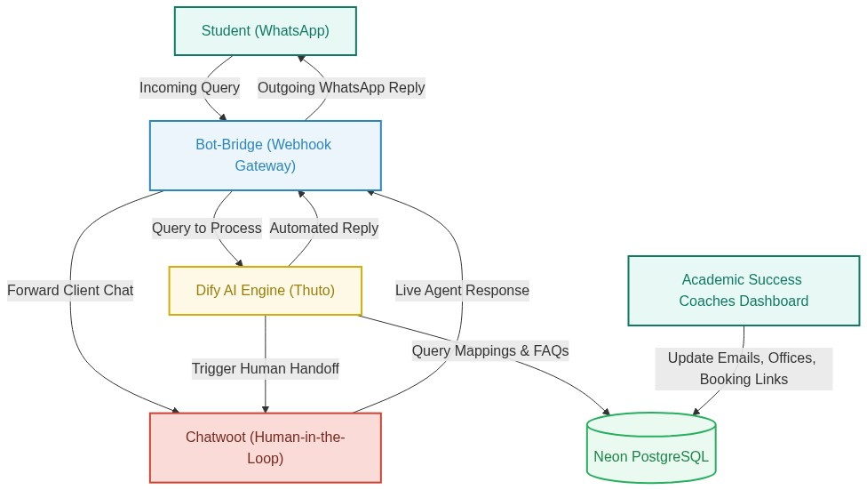

5.1.1 Process Overview

The current Academic Success Coach lookup process begins when a student requires academic guidance. The student must navigate the static university website listings or contact the student support desk via email. The support staff manually consults internal directories, emails, or spreadsheets to identify the student's faculty, their assigned coach, office location, and appointment booking link. The staff then manually emails these details back to the student. This process is prone to delays, manual overhead, and outdated listings.

5.2.1 Process Overview

The profile update process begins when a coach's contact details, office location, or booking link changes. The coach must draft and email an update request to the web or database administrator. The administrator manually edits the directory sheet or website page. Because this process relies on manual requests and queue turnaround times, directory information frequently remains outdated, causing student confusion.

5.3. Future (To-Be) Process
The future process utilizes the LEAF platform to automate and simplify these workflows: 1. Direct Profile Management: Academic Success Coaches log in securely via Clerk to the LEAF Web Console and update their details (office, clusters, booking links) directly. This writes instantly to the Neon PostgreSQL database. 2. Automated Chatbot Queries: When a student interacts with the LEAF chatbot (built on Dify and integrated into Chatwoot), they select their faculty or programme. The chatbot queries the Neon database to retrieve the coach's details, booking links, and FAQs, returning them instantly. 3. Live Agent Handovers: If a student's query is complex, Chatwoot routes the conversation to a live administrative support agent dashboard for real-time human assistance.

User Stories

Student User Stories
- (Find Coach): As a student needing academic guidance, I want to query the LEAF chatbot to find my assigned Academic Success Coach based on my faculty or programme, so that I can contact them.
- (Retrieve Resources): As a student seeking study support, I want the chatbot to provide links to verified resources and study guides, so that I can improve my academic performance.
- (Answer FAQs): As a student with questions about registration or module changes, I want the chatbot to answer my inquiries instantly, so that I get immediate help 24/7.
- (Escalate Support): As a student with a complex issue, I want to request a live agent chat so that I can speak directly to a student support officer.
- (Chat History): As a student interacting with the chatbot, I want to view my past conversation history so that I can reference previously shared links and advice.

Academic Success Coach (ASC) & Admin User Stories
- (Profile Updates): As an Academic Success Coach (ASC), I want to log in to the web console and update my office location and appointment links, so that students always see my latest contact details.
- (Resource Uploads): As an ASC, I want to add new academic resources and study material in the console, so that students can access them through the chatbot.
- (FAQ Management): As an ASC, I want to create and edit frequently asked questions, so that the chatbot answers student inquiries accurately.
- (Cluster Mappings): As an ASC, I want to assign myself to specific programmes and faculties, so that students in those streams are correctly routed to me.
- (Access Management): As an admin, I want to define role-based tab access permissions so that only authorized coaches can modify system metadata.
- (Audit Control): As an admin, I want to view user access logs to track modifications made to coach assignments and metadata.

Business Requirements

- LEAF requires a standardized, reliable, and auditable process for managing student academic success inquiries from initiation to resolution.
- LEAF requires an accessible and user-friendly interface that reduces student effort when searching for coach contact information and appointment links.
- LEAF requires a mechanism to proactively flag and direct students to their respective Success Coach based on their registered faculty or programme.
- LEAF requires coach assignment queries to be supported by accurate student information, including programme registration, module registration, and faculty mappings.
- LEAF requires coach profile and contact directory maintenance to minimize manual administration through direct self-service updates by the coaches themselves.
- LEAF requires conversational chatbot answers to be derived from a verified database source of truth, ensuring consistent, traceable, and reliable guidance.
- LEAF requires chatbot support resources to be dynamically aligned with students' registered modules, programs, and study tracks.
- LEAF requires seamless conversation routing and handover capabilities between the automated chatbot and live student support administrators.
- LEAF requires administrative tasks such as directory updates, resource uploads, and FAQ definitions to be centralized in a secure web console.
- LEAF requires comprehensive record logs of all chatbot conversations and administrative actions for reporting, service improvement, and audit purposes.

Functional Requirements

Data Integration & Management (Neon PostgreSQL)
- The system shall store Academic Success Coach (ASC) details including name, email, cluster assignments, office location, and booking links.
- The system shall store academic structures including faculties, programs, modules, and study resources.
- The system shall support inline database seed synchronization for faculties, programs, modules, resources, and FAQs.
Clerk Authentication & Access Control
- The system shall authenticate Academic Success Coaches and administrators securely using Clerk Single Sign-On (SSO).
- The system shall enforce role-based access control (RBAC), restricting console write actions to authorized personnel.
Dify Chatbot AI Integration
- The chatbot shall connect to the Neon PostgreSQL database to dynamically retrieve coach contact details and assignments.
- The chatbot shall query program and module structures to resolve student support inquiries.
- The chatbot shall answer student questions using the verified FAQ database.
Chatwoot Conversation Hub
- The system shall embed the Chatwoot widget inside the web layout for seamless student access.
- The system shall track, record, and log all chatbot conversations.
- The system shall support manual handover of chatbot dialogues to active student support officers.
Hosting & Infrastructure (Coolify & Oracle Cloud)
- The system shall deploy Next.js, Dify, and database adapter services in containerized environments.
- The system shall orchestrate build and deployment pipelines using Coolify on an Oracle Cloud VPS.
- The system shall configure secure SSL and public domains for the chatbot web services.

System Requirements

Security & Privacy (NFR)
- The system shall secure all administrative routes and API endpoints using Clerk Authentication and JSON Web Tokens (JWT).
- The system shall enforce Role-Based Access Control (RBAC) to restrict console write operations (e.g., updating FAQs and resource links) to authorized administrators and Academic Success Coaches.
- The system shall comply with regional data privacy regulations (e.g., POPIA) regarding user information.
- The system shall maintain an audit log of all administrative profile edits, resource updates, and role modifications.
Performance, Scalability & Availability (NFR)
- The system shall support up to 1,000 concurrent chatbot queries during peak academic periods with a response latency of under 2 seconds.
- The system shall maintain 99.9% uptime during active academic semesters, hosted on self-managed Oracle Cloud instances.
- The Neon PostgreSQL database shall run incremental daily backups and weekly full backups.
- Automated conversation handovers and agent notifications in Chatwoot must trigger within 60 seconds of a student escalation request.
Usability & Accessibility (NFR)
- The student-facing chatbot widget shall comply with Web Content Accessibility Guidelines (**WCAG 2.1 Level AA**) for screen reader compatibility.
- The LEAF web console and chatbot interface must be fully responsive and optimized for mobile and desktop web browsers.
Technical & Environmental Constraints
- The database adapter must connect securely to Neon PostgreSQL using connection pooling (pg.Pool).
- The chatbot functionality must be powered by a self-hosted or API-connected Dify instance.
- The conversational interface must integrate Chatwoot via its client-side JavaScript SDK using a centralized site token.
- All services must be deployed and managed as containerized applications via Coolify on Oracle Cloud Infrastructure (OCI).

10. Pricing, Operating Costs & Projections

10.1 Estimated Platform Operating Costs
- Cloud Hosting (Oracle Cloud Infrastructure): VM.Standard.A1.Flex Always Free compute shape (4 OCPUs, 24 GB RAM, 200 GB SSD) resulting in R0.00 base monthly costs. For paid scaling shapes, the estimated baseline is R1,080.00/month.
- Database Storage (Neon PostgreSQL Serverless): Free tier allows 3 GB storage at R0.00/month. The Launch Tier (R342.00/month) provides 10 GB storage and dedicated compute capacity for active terms.
- AI LLM API Consumption (Google AI Studio - Gemini 1.5 Flash): Evaluated at R1.35 per 1M input tokens and R5.40 per 1M output tokens. Under active terms with 10,000 active students (60,000 total monthly queries), the baseline cost is estimated at R398.16/month (based on 6 queries per student/month) due to efficient context caching.
- Authentication (Clerk): Free tier supports up to 10,000 monthly active users (MAUs) at R0.00/month. Scaling above 10,000 MAUs uses the Pro plan at R450.00/month.

10.2 Service Pricing Model & Profit Margins
- Flat Monthly Subscription: We charge the department a flat rate of R8,000.00/month, covering up to 10,000 Monthly Active Users. Since our actual running cost is R1,550.16/month, this yields a monthly gross profit of R6,449.84 per department (81% profit margin).
- Tiered Expansion: For scaling above 10,000 users, the pricing is adjusted to R11,000.00/month (up to 12,000 MAUs) and R18,000.00/month (up to 20,000 MAUs), preserving high margins while offering clear value to the institution.

10.3 3-Year Agency Profit & Expansion Projections
- Year 1 (5,000 Users/Month): Expected Monthly Cost (COGS): R1,351.80. Monthly Revenue: R5,500.00. Monthly Net Profit: R4,148.20 (Annual Net Profit: R49,778.40).
- Year 2 (10,000 Users/Month): Expected Monthly Cost (COGS): R1,550.16. Monthly Revenue: R8,000.00. Monthly Net Profit: R6,449.84 (Annual Net Profit: R77,398.08).
- Year 3 (15,000 Users/Month): Expected Monthly Cost (COGS): R2,199.24. Monthly Revenue: R11,000.00. Monthly Net Profit: R8,800.76 (Annual Net Profit: R105,609.12).

